Title: CST 370 Lab 1

Author: Julia Diliberto

Date: January 10, 2016

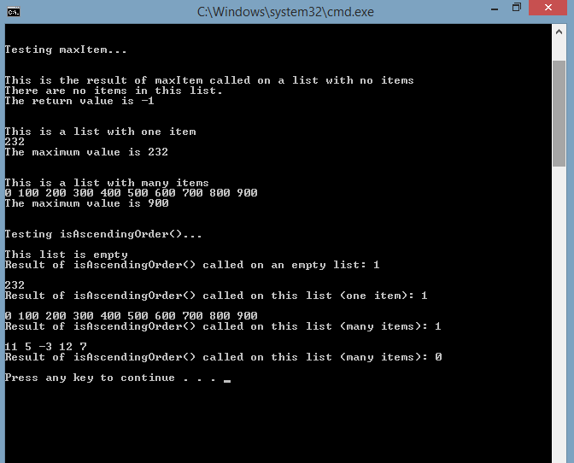

This screenshot shows the results of maxItem() called on an empty list (empty list message and return value of -1), a list with one item (correct return value) and a list with many items (correct return value); and the results of isAscendingOrder() called on an empty list (empty list message and return value of 1), a list with one item (return value of 1) and two lists with many items. The first is ordered and returns 1 and the second is unordered and returns 0.